POWER BI DASHBOARD CHALLENGE
TASK 1 – DATASET SELECTION & IMPORT
● Choose one dataset from the given list.
● Import data into Power BI Desktop (via Web).
● ✅ Task: Verify data is loaded correctly.
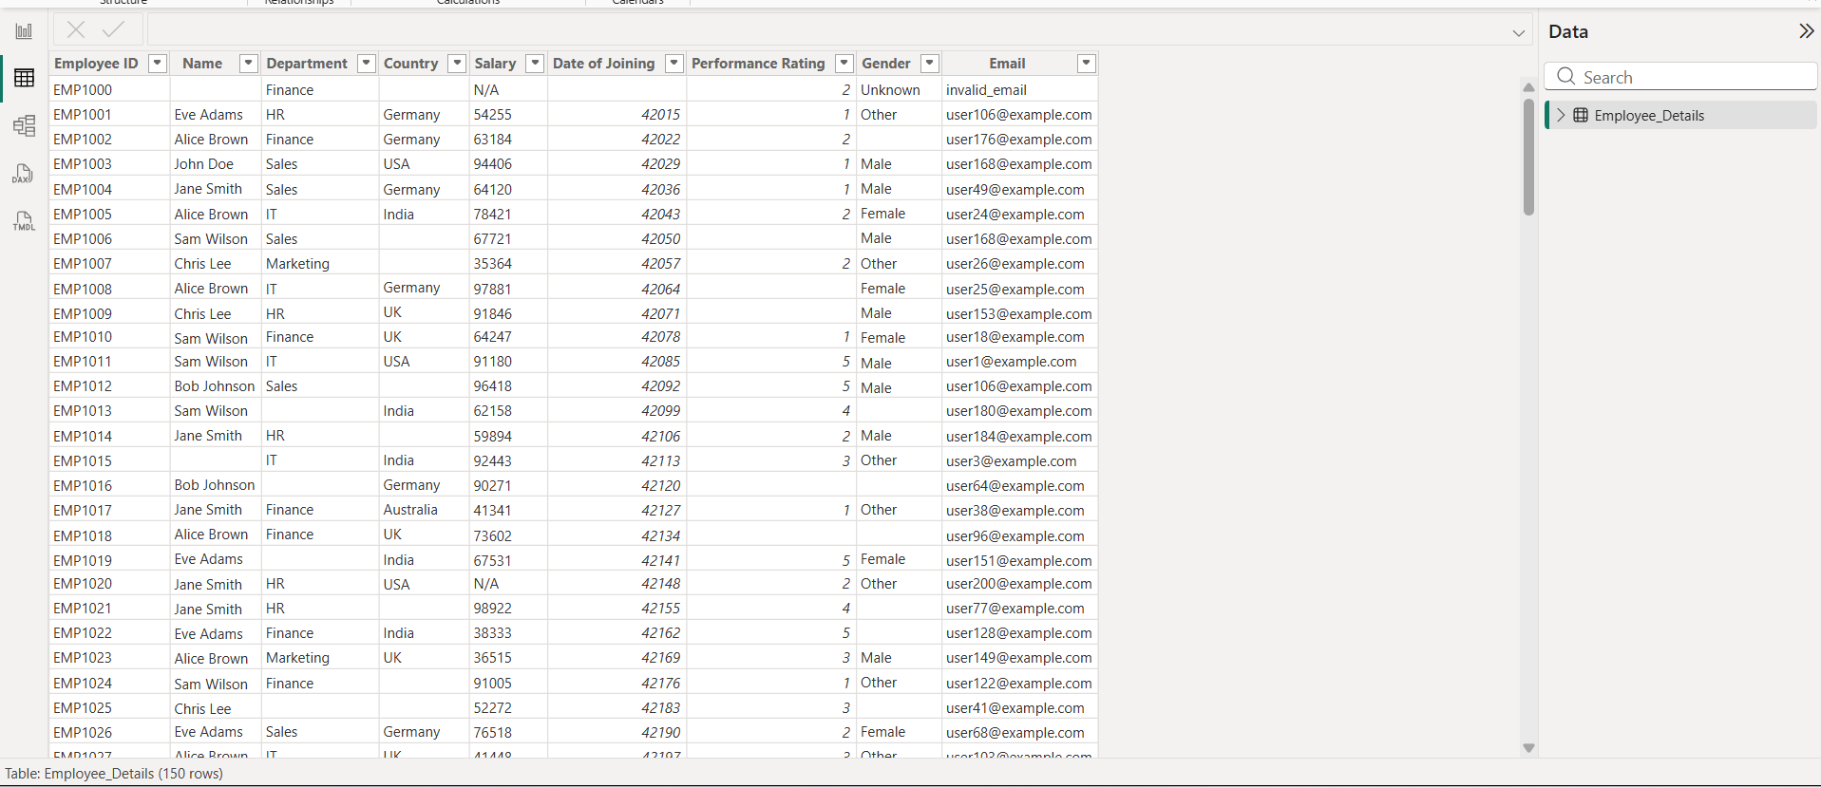
OBSERVATION:
The Employee Details Excel dataset was successfully imported into Power BI Desktop. All rows and columns were loaded correctly without any errors. The column names and data were displayed accurately, making the dataset ready for data cleaning, transformation, and analysis.

